Launch Linux EC2 instances in two regions using a single Terraform file.

**Step 01:** Creating provider file for two different regions

terraform {

  required_providers {

    aws = {

      source  = "hashicorp/aws"

      version = "~> 5.0"

    }

  }

}

# Configure the AWS Provider

provider "aws" {

  alias  = "east1"

  region = "us-east-1"

}

# Configure the AWS Provider

provider "aws" {

  alias  = "east2"

  region = "us-east-2"

}

**Step 02:** Creating a resource file for EC2 Machines

variable "instance_type" {

  description = "Type of EC2 instance"

  default     = "t2.micro"

}

variable "ami_ids" {

  description = "Map of AMIs by region"

  type        = map(string)

  default = {

    "us-east-1" = "ami-0953476d60561c955"

    "us-east-2" = "ami-06c8f2ec674c67112"

  }

}

resource "aws_instance" "linux_instance_us-east-1" {

  provider      = aws.east1

  ami           = var.ami_ids["us-east-1"]

  instance_type = var.instance_type

  tags = {

    Name = "Linux US East1"

  }

}

resource "aws_instance" "linux_instance_us-east-2" {

  provider      = aws.east2

  ami           = var.ami_ids["us-east-2"]

  instance_type = var.instance_type

  tags = {

    Name = "Linux US East2"

  }

}

**Step 03:** Running the terraform command

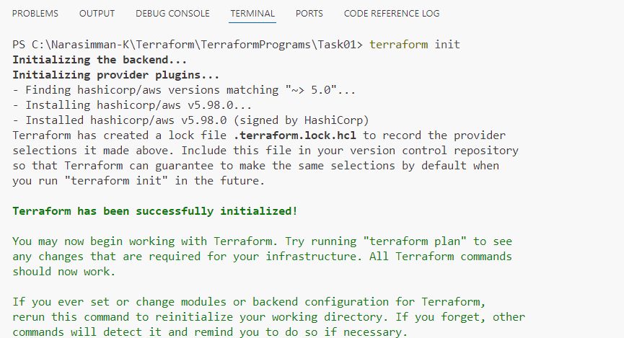

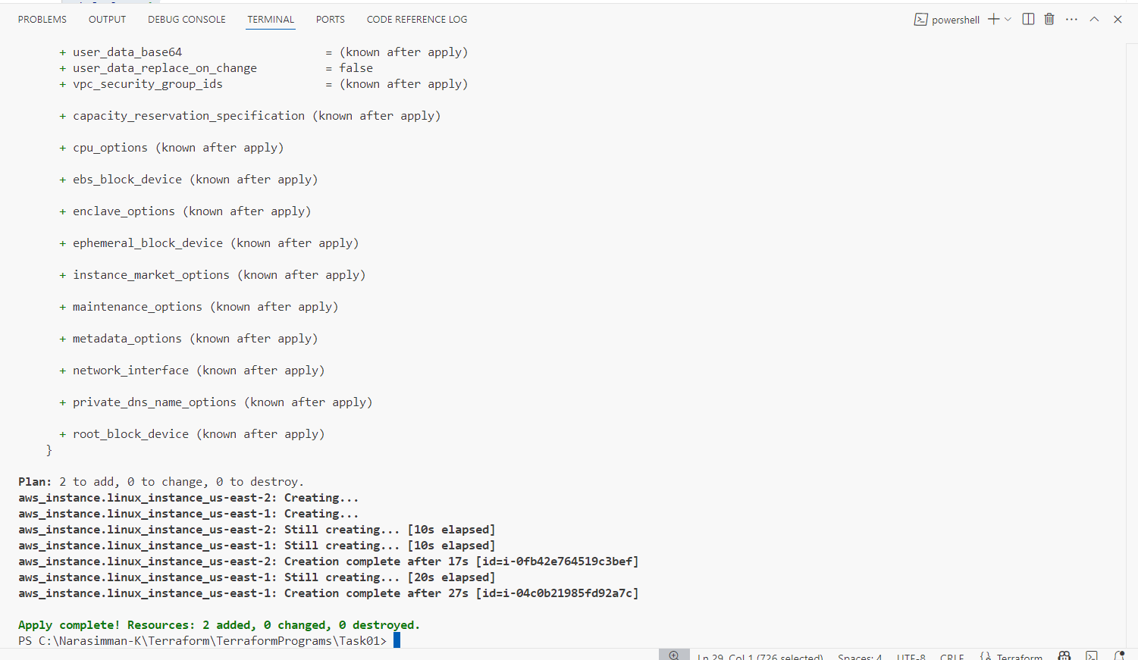

**Step 05:** Verifying the instances have been launched successfully

US-east-1

US-east-2

**Step 06:** Destroying the EC2 Instance

